

**Ministry of Social Development**

KINGDOM OF LESOTHO

October 2021

Submitted By

**SYSTEM REQUIREMENT SPECIFICATION**

VAC HELPLINE SYSTEM

Table of Contents

Table of Figures iii

Introduction 1

Functional Requirements & Features 1

Call 1

Walk-In 1

Case Capture 3

System Case Capture Form 3

Form choices 8

Case Categories 11

Case Capture process. 15

Other Notes 15

Calls and call configurations 16

IVR – Interactive Voice response 16

Call process flow 17

API and Integrations 17

Quality Module 18

QA Monitoring Form 18

User Management 21

Administrator 21

Social workers 21

Supervisor 21

Case Escalation Process 22

Reporting Module 22

Pivot Reports 22

Comprehensive Reports 23

Presence Status 23

Approval Form 24

# Table of Figures

Figure 1: Call pop up form - first page 1

Figure 2: Contact search form for new walk-in case 2

Figure 3: Reporter search results for new walk-in case 3

Figure 4: Tabbed case capture form 5

Figure 5:Case Capture flow 12

Figure 6: Other Sources Information flow 13

Figure 7: Quality Analysis Form 18

Figure 8: Pivot Report 20

Figure 9: User Presence Page 22

# Introduction

In 2005, a multi-sectoral task force was established in Lesotho to provide technical support and to initiate the establishment of a National Child Helpline. The Task Force comprised of representatives from Ministry of Justice, Human Rights and Correctional Services (Probation Unit), Ministry of Health & Social Welfare, Ministry of Gender, Youth, Sports and Recreation, Ministry of Education & Training, Ministry of Home Affairs (Child and Gender Protection Unit), NGO-C and UNICEF.

Through a consultative process with organizations working with and for children, a concept note for the Lesotho Child Helpline was developed.

# Functional Requirements & Features

### Call

This is the major case source at the helpline through the 116 toll free number. The agents at the helpline collect structured information from callers following the case capture process as detailed herein. Upon receiving a call, the CRM pops a case form with caller details and historical cases if already exists determined by the caller phone number.

When a call is received by a user and the form pops, the user will be presented with a brief history of the caller in terms of historical cases if any, the number of times they have called, the last call date and any other relevant information besides the prefilling of reporter details on the form.

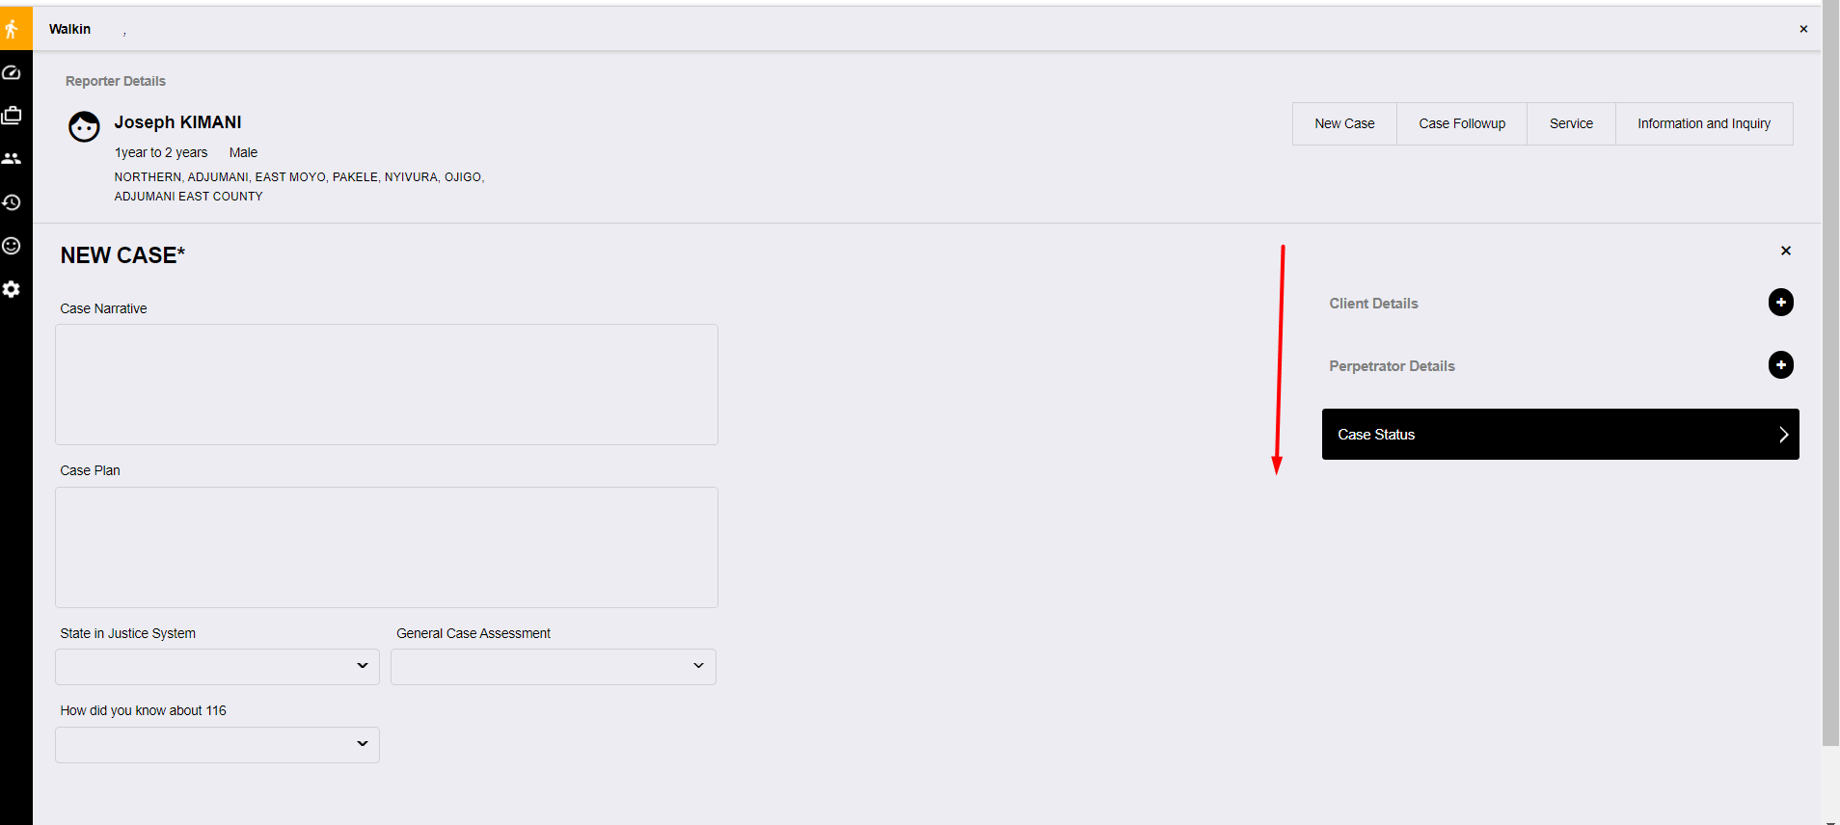

Figure : Call pop up form - first page

### Walk-In

This is mainly designed for non-call communication channels. For case reports from public members walking into the helpline center or any other partnering institution to report a case related to VAC. The case capture process is universal to the different communication channels as case capture details are standardized.

Upon clicking new case, the user will be presented with a contact search form with phone. email and name. The users are search by either one, two or all the three parameters.

Search results will be displayed and the user selects the appropriate contact as the current reporter where the details of the selected user shall be prefilled on the reporter details of the case form.

This search form shall only be presented for walk-in cases as cases from the other channels originate from a record already linked to contact and will have the reporter details prefilled with such details.

The diagrams below display how the contact search form and the search results shall be:

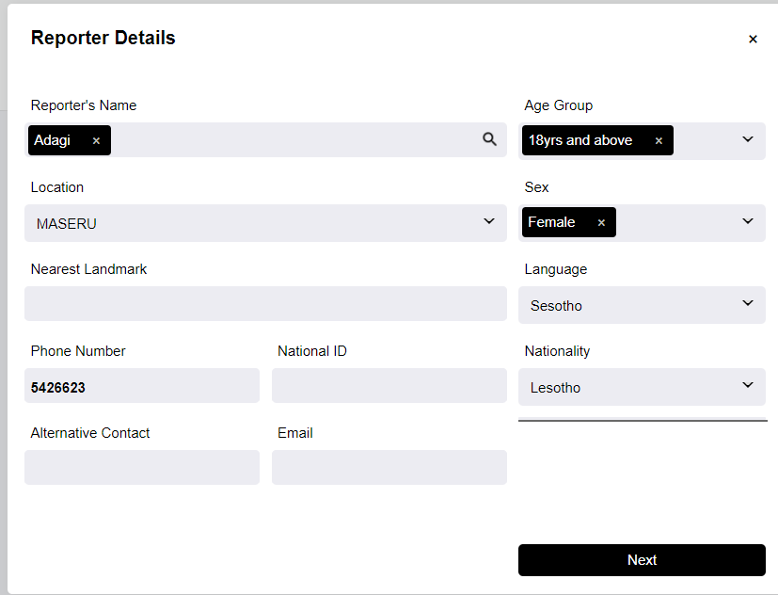

Figure : Contact search form for new walk-in case

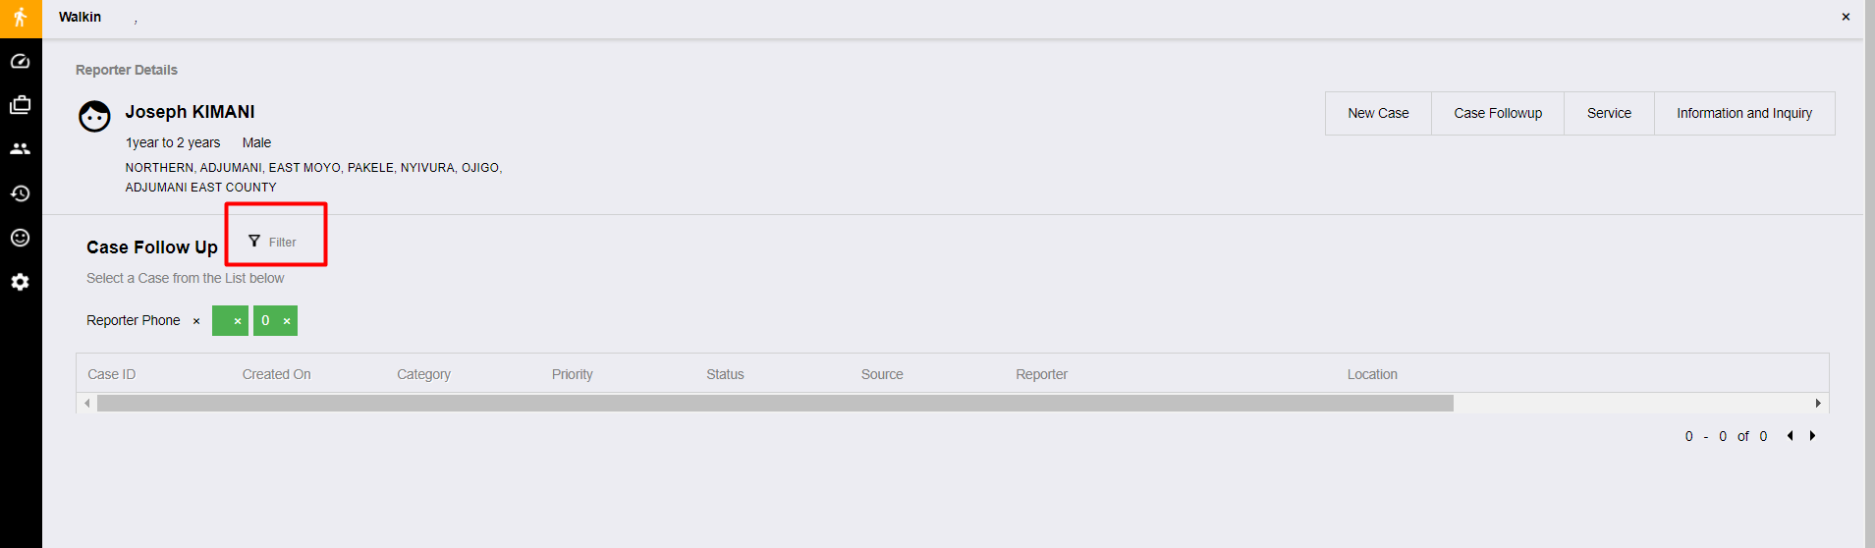

Figure : Reporter search results for new walk-in case

## Case Capture

Case capture involves the different system forms used by the communication channels for data capture. There three forms to be designed: System form, mobile app form and web-online form.

The system form for walk-in/call/mobile is the major form while the web-online form is a subset of the system form.

### System Case Capture Form

This defines the major case capture fields and process flow.

The fields are as follows:

|  |  |  |
| --- | --- | --- |
| # | Grouping | Field(s) |
| 1. | Report Details | Name, gender, phone number, language, Age Group, location (hierarchical), Nearest Landmark,  Alternative Contact (Text Field)  Email Address (Text Field), alternative contact, reporter tribe (select tribes), nationality and ID/Refugee Number |
| 2. | Case Categorization | Case Category (Select Categories), case subcategory (select sub categories), if reporter is client (reporting for self) |
| 3. | Client Details *(Collected if the reporter is different from the client)* | Name, gender, phone number, language, Age Group, nationality, location (hierarchical), Nearest Landmark,  Alternative Contact (Text Field)  Email Address (Text Field), client tribe, relationship to reporter, relationship comment, health status |
| 4. | Additional Client Details | DOB (Date of Birth),Age (in months and years),Guardian name, guardian marital status, disability status, disability type, if referred to receive special services, HIV status, household type, number of adults in household, occupation of household head, if client attends school, name of school, client school level, type of school, school attendance, school attendance reason, school address, if client is married, spouse name, spouse profession |
| 5. | Perpetrator Details | Name, gender, relationship with client, if the perpetrator share household with the affected person, location (hierarchical), Nearest Landmark, age, age group, perpetrators guardian name, tribe, health status, marital status, additional details |
| 6. | Case Narrative | Narrative, case plan, status in the justice system, general case assessment, related files, priority |
| 7. | Services Offered | Services offered, appropriate referrals |
| 8. | Case Action | Case action (status), status comment, how one got to know about 116 |

The case capture form shall be implemented in a tabbed wizard whereby the information is captured sequentially. The fields shall be grouped as above in the order of: Reporter Details, Client Details, Additional Client Details, Case Category, Case Perpetrator, Case Narrative, Services Offered and Case Action. This way, the user of the system is guided on the information they are supposed to get from the reporter in a structured manner without any important information.

Figure : Tabbed case capture form

### Form choices

These are the choices fields with pre-defined options. They are as describe below:

|  |  |  |  |  |  |
| --- | --- | --- | --- | --- | --- |
| # | Name | Options | | | |
| 1. | Case Categories (Applicable for VAC) | Provided separately | | | |
| 2. | Relationship |  | | | |
| 3. | HIV status | * Negative * Positive * Unknown | | | |
| 4. | Escalate to | * Supervisors | | | |
| 5. | Case Action (Status) | * Escalate * Pending * Closed | | | |
| 6. | Services Offered | * Appropriate Referrals * Awareness * Educational Support * psycho-social support * Report to Police * Medical Support * Legal Support * Basic Need Support * Resettlement * none * Others | | | |
| 7. | Case Priority | * High Priority * Medium Priority * Low Priority | | | |
| 8. | Case Assessment | * Progressing * Stagnating * Retrogressing * Unknown | | | |
| 9. | Referral Organizations (to) | * LCS * MOSD * Judiciary/Children’s Court * Probation Unit * Police/CGPU * Health Facility * NGOs/CSOs/CBOs * Care facilities and Care points * Legal Aid * Other | | | |
| 10. | Referrals organizations (from) | * Police/CGPU * Health Facility * Care facilities and Care points * NGOs, CSOs | | | |
| 11. | Justice System | * At Police * In Court * Probation Officer * Social Worker * Court Intermediary * Unknown | | | |
| 12. | Health Status | * Healthy * Mildly Sick * Chronically ill * Depressive * HIV Positive * COVID- 19 * Substance abuse and addiction * Unknown | | | |
| 13. | School attendance | * Consistent * Inconsistent * Dropped out * Unknown | | | |
| 14. | School level | * Nursery * Primary, * Secondary * Tertiary | | | |
| 15. | School Type | * Government Boarding * Private Boarding * Government Day * Private Day * Government Day and Boarding * Private Day and Boarding * None | | | |
| 16. | Disability referral | * Police * MOSD * Health Facility * Care facilities * NGOs, CSOs | | | |
| 17. | Disability | * Hearing * Motor * Mental * Intellectual * Visual * Physical * Multiple Disabilities * Down Syndrome | | | |
| 18. | Occupation | * Small Scale Business * Large Scale Business * Public Servant * Casual Laborer * NGO Workers * Unknown | | | |
| 19. | Profession | * Small Scale Business * Large Scale Business * Public Servant * Casual Laborer * NGO Workers * Unemployed * Peasant * Farmer (Commercial) * Farmer (Subsistence) * Unknown | | | |
| 20. | Household Types | * Child Headed * Single Parent * Both Parent * Grand Parents * Guardian * Others * Unknown | | | |
| 21. | Marital Status | * Married * Single * Divorced * Cohabiting * Separated * Widowed * Unknown | | | |
| 22. | Relationship | * Father * Mother * Sister * Brother * Grandfather * Grandmother * Uncle * Aunt * Cousin * Other family member * Foster Father * Foster Mother | | * Stepfather * Stepmother * Step brother * Step sister * Teacher * Worker in care facility * Friend of the child * Peer/ Not a friend * Other not related adult * Nanny/House help * Neighbor * Unknown | |
| 23. | Age groups | * 0-4 * 5-9 * 10-13 * 14-17 * 18-30 * 31-60 * Above 60 (Older Persons) * Unknown | | | |
| 24. | Gender | * Male * Female * Others * Unknown | | | |
| 25. | Languages | Sesotho and English |  | |  |

### Case Categories

|  |  |  |
| --- | --- | --- |
| # | Category | Subcategory |
|  | Abuse | |
| 1. | Murder | * Child Death due to Abuse * Attempted Murder * Child Sacrifice * Concealment of birth * Mysterious Death * Poisoning * General |
| 2. | Physical Abuse | * Corporal Punishment * Electric-shocking * Beating * Burning * General |
| 3. | Emotional Abuse | * Labelling * Witness to Violence/Abuse * Bullying * Verbal Attack * General |
| 4. | Child Trafficking | * Internal Trafficking * Cross Border Trafficking * Abduction/Kidnapping * General |
| 5. | Child Exploitation | * Child Labour - Commercial * Children used for Criminal Activity * Children used for Begging * Child Labour - Domestic * Child Labour - Bonded * Child Labour * Commercial Sex Exploitation * Herders * General |
| 6. | Child Neglect | * Denial of Education * Child Malnutrition * Child Abandonment * Child Maintenance * General |
| 7. | Sexual Abuse | * Defilement * Exposure to Pornographic Materials * Sodomy * FGM (Female Genital Mutilation) * Teenage Pregnancy * Early/Forced Marriage * General |
| 8. | Online Child Sexual Abuse And Exploitation | * Online Extortion and Blackmail * Victim of Online Sexual Exploitation * Exposure to Online Child Pornography * Victim of Online Child Pornography * Attempted Defilement * Victim of Online Child Sexual Exploitation * Online Grooming for Sexual Purposes * Unwanted Sexting * Revenge Pornography * General |
|  | Counselling |  |
| 1. | Boy/Girl Relationship |  |
| 2. | Student or Teacher Relationship | * Teacher Problems * Student in Problems with School Authority * Abortion |
| 3. | Stress/Depression |  |
| 4. | Self Esteem |  |
| 5. | Reproductive Health Issues |  |
| 6. | Loss and Grief |  |
| 7. | Career Guidance |  |
| 8. | Juvenile Delinquency |  |
| 9. | Family Issues | * Divorce/Separated Parents in Conflict * Sibling Relationship * Family Member in Conflict |
| 10. | Parent or Child Relationship | * Unmanageable Children |
| 11. | Parental Guidance | * Positive Parenting * Coping with Single Parenthood |
| 12. | Peer Influence |  |
| 13. | HIV Counselling |  |
| 14. | Child Custody | * Institutionalization * Adoption * Paternity/Maternity Rights |
| 15. | Child In Conflict with the Law | * Child Imprisonment * Juvenile Delinquency * Child to Child Sex |
| 16. | Marital Issues |  |
| 17. | Addiction | * Drugs * Smoking * Alcohol * Gambling * Gaming * Pornography * Social Media/Internet * Food * Masturbation |
| 18. | Mental Issues |  |
| 19. | Legal Issues | * Child in need of representation * Child Witness * Law in Conflict with Children's Rights * Child in Conflict with the Law * Child Imprisonment * Child Imprisoned with adult Person * Maintenance, Custody and Access * Pre-Trial Briefing |
| 20. | Child to Child Sex |  |
| 21. | Lost Child | * Seeking shelter * Missing Child * Homeless Child * Lost Child |
| 22. | Life Skills |  |
| 23. | Property Rights | * Inheritance issues * Property grabbing |
| 24. | Differently Abled Persons | * Deaf * Visually Impaired * Mental Disability * Physical Disability |
| 25. | Orphans | * Child headed families * Orphan in need of care and support * Orphan in need of school fees * Orphan living with elderly person * Orphan living with HIV-Infected person |
| 26. | Street Child |  |
| 27. | Discrimination | * Age * Ethnicity * HIV/AIDS * Marginal/Vulnerable Groups * Criminal Record/Ex-Prisoner * Access to Education |
| 28. | Run Away Child |  |
|  | Medical Aid | * In need of medical assistance * Access to health care * Concerns about illnesses |
|  | Information Inquiry | |
| 1. | Pre-trial Briefing |  |
| 2. | Inquiry on Other Services |  |
| 3. | Information on Helpline Services |  |
| 4. | Financial Aid |  |
| 5. | Employment/Job |  |
| 6. | Topical Issues (Child rights, Biology etc) |  |
| 7. | Case Update |  |
| 10. | Birth Registration |  |
| 11. | Appreciation |  |
| 12. | In Need of School Fees |  |

### Case Capture process.

This shows the flow of the case capture process. The reporter details can be prefilled on call if the details exist and for all historical cases.

New Case

Reporter details

Information Inquiry

Client Details

Perpetrator Details

Case Details

Services Offered

Case Action/Closure

Follow Up

Figure :Case Capture flow

### Other Notes

For a walk-in case, allow the user to first search existing reporter records to prevent duplicate data by identifiers such as phone number or name.

All the cases created within the system should be identifiable by a unique case number and tagged to the source record e.g. call or walk-in where applicable.

Case records should be ordered in descending order by date created and easily filtered by fields such as date, creating user, reporter, and client and/or case number among others.

A case view of each case should provide the entire details of a case in a printable version or a PDF export.

A case form automatically pops when a user receives a call and/or clicks the create case button. This prevents other activity or navigation on the current tab unless the form is submitted or disposed-off.

There shall be maintained case edit history/trail that would show the case edit by and when.

## Calls and call configurations

The system will allow incoming calls from a reporter or a client who is reporting a case. The toll free number shall be used for the VAC case reporting.

Calls can be transferred within the call center while at the same time the supervisor can budge into an ongoing call to listen in or give some inputs to both parties.

### IVR – Interactive Voice response

This refers to pre-recorded audio configured to guide the callers before a call is queued and received by agents. If the caller does not get any agent to handle the call, they can opt to leave a voicemail with the key details to enable the helpline to follow up. The helpline IVR can have the following guiding audios:

* A welcome message with greetings
* Language preference (Selection) and skill set routing
* Hold music or general information played when all Social workers are busy on calls
* Voice mail for a call back if the call has not gone through to any of the Social workers

### Call process flow

Welcome IVR

Call Answered?

Exit IVR

Voicemail?

Voicemail message IVR

Case Capture/Follow Up

## API and Integrations

The system shall entail an API and endpoints for exposing data securely to partnering organizations and systems. The endpoints may include: contacts, clients, cases, calls, etc.

The system should also have a provision to consume APIs from other systems. Data from other systems shall be pushed to the system and used to create cases by system users.

## Quality Module

All the voice calls handled by the Social workers shall be recorded and the same availed for quality analysis by supervisors. The supervisor shall rate the Social workers based on set parameters as described in the section below.

To analyze the cases and supervisor shall listen to the calls in the system, evaluate and validate if the same is in line with set policies and general client service practice.

The supervisor responses are categorized as soft skills, counselling knowledge, updating the system, etc.

The supervisor will have the option of following the activities on the calls:

1. Barge into the call – without the Social workers being aware of it
2. Snoop into the call – While listening to the call, the supervisor can prompt to the Social workers any information without the client able to listen.
3. Confer – Where the supervisor, Social workers and the client are able to have a conversation

### QA Monitoring Form

It will have the following broadly classified headings

|  |  |  |
| --- | --- | --- |
| # | Category | Fields |
| 1. | Opening / Greeting of the call | * Use of call opening phrase * Section comment |
|  | Listening skills | * Caller was not interrupted during the conversation * Empathizes with the caller on the issues raised * Rephrases or paraphrases the issues / query back to caller. * Uses "please" and "thank you" when requesting and receiving information. * Does not hesitate or sound unsure when providing feedback. * Section comment |
| 2. | Pro-activity | * Willingness to solve additional issues not proposed by the client. * Confirmation of client's satisfaction with action points given * Follows up on case updates * Section comment |
| 3. | Resolution/counselling provided | * Gives accurate and precise information to the caller. * Correct use of language. Wordings, phrases, greetings etc. * If not sure of the information, did the counsellor consult * Follows accurate steps while addressing the client's problem * Explains in detail to the caller the process of doing the problem solving * Section comment |
| 4. | Hold procedures | * Provides an explanation/instructions to the caller before placing on hold/transfer and obtains consent * Revisits caller, providing status and offering. Always thanks the caller for holding. * Section comment |
| 5. | Closing the call | * Demonstrates appreciation and thanks caller for calling * Section comment |
| 6. | General analysis feedback | * Feedback comment |

The response score shall be as below:

1. No - 0 Points
2. Partially - 1 Point
3. Yes - 2 Points

The QA form in the system shall be like this but covering all the sections described above.

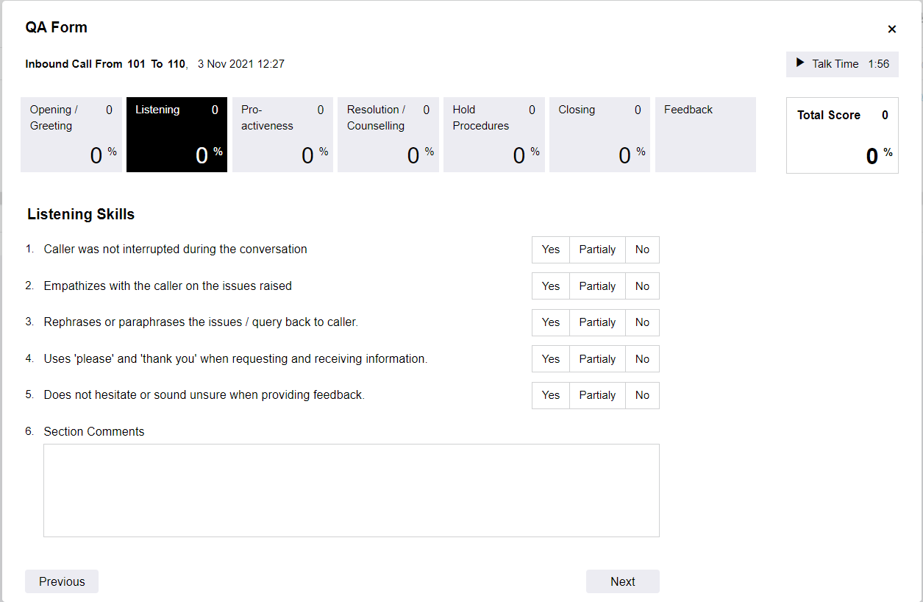

Figure : Quality Analysis Form

Depending on the scoring the overall QA percentage shall be calculated.

* All calls shall be listed for QA and analyzed calls shall be moved to a separate list to avoid a repeat. The analysis can be done by sampling or any other way as may deem fit for the supervisor and the helpline.
* The supervisor can search for a particular call by either agent name, phone number or related case number.
* The fields to be listed on the QA call record shall include but not limited to: Name, case number, date of call, Time of call, Duration of call, Status of call, if analyzed and an option to analyze if not yet.
* The monitoring form shall have an audio player with options to pause or replay sections.
* All results shall be available for viewing by the supervisor and the agent responsible for the call.

## User Management

The system shall have the following user levels: administrator, counsellor/agent and supervisor.

Every user level shall dashboard representative of their account roles and activity including statistics of calls and cases based on parameters such as categories, status, gender, districts, priority and any other applicable field. The dashboards can also have graphical displays line & pie charts, bar graphs, etc.

### Administrator

This is a general system administrator responsible for general system configurations, the can view cases, they have minimal or no action. The following are some of the roles by administrators:

* Create and update configurable parameters such as case categories and services offered.
* Manage system users.
* View reports.

### Social workers

Social workers handle calls and are mainly based at the call center. They are trained to offer first-line support for VAC. Additionally, they:

* create cases from calls
* escalate cases to supervisors
* view their own cases.
* Can search cases from all cases

### Supervisor

A supervisor is the call center manager who is in charge of Social workers/agent work affairs and to ensure they are within the set policies of the helpline. They:

* Can create cases.
* View all cases with an option to update.
* Perform QA on calls.
* Propose system settings and updates to the administrator.

## Case Escalation Process

This is the process in which a case goes through before it’s closed. A case may be closed at the time of creation by the Social workers but sometimes it requires attention from a higher level of the user hierarchy.

A Social workers can escalate a case to a supervisor who in turn can escalate the case to a case manager, the case manager assigns cases to case workers who in most of the time are in the field.

## Reporting Module

All activities done on the case management system will result into reports which are used by the supervisors, management and others to analyze the trends and be proactive and take corrective measures to mitigate situations. Both call and case reports shall have list and statistical (pivoted) reports.

There shall be 2 main line of reports.

* Case Management Report – reports regarding case management.
* Call Management Reports – reports pertaining calls.

### Pivot Reports

Pivot report refers to statistical description of the data captured generated by a system user based on select report fields. It presents fields on an X and Y axes form and filtered by date and/or date range.

This gives a permeation & combination of the type of reports required and the different data required. Additional fields can be provided for filtering the reports. This applies to both call and case reports.

The report should be printable or exportable to acceptable formats such as PDF or spreadsheet.

The diagram below shows a sample pivot report page:

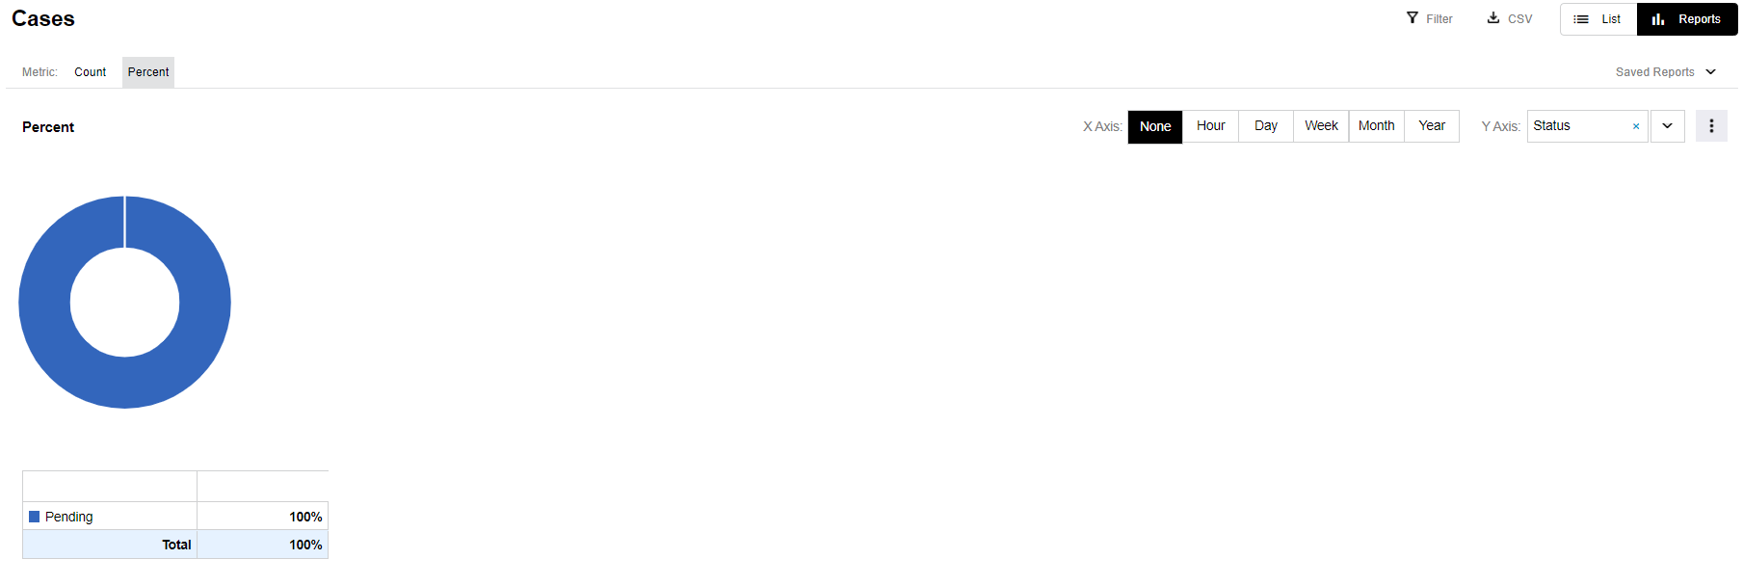

Figure : Pivot Report

### Comprehensive Reports

These are the main types of reports with listings of records are collected by the system. The module should provide filters for all of these kinds of reports to allow users get what is needed for a particular purpose. The filter may include date created, location, categories, gender, status among others.

These reports include:

* Call Reports
* Case Reports
* Social workers Reports
* Performance Reports

The comprehensive reports shall have export option to formats such as XLSX, CSV, XLS and PDF either for further analysis or presentation.

## Presence Status

This feature will show the supervisor the status of all system users and activities been engaged in. It shows the user status within the system and both login & queue status where applicable.

This also shows the number of users per particular queue status as follows:

* Nos of Social workers Logged into the queue
* Nos of Social workers available
* Nos of Social workers busy on activities
* Nos of Social workers on Break or Training
* Nos of Social workers Offline

The diagram below shows a sample page for user presence:

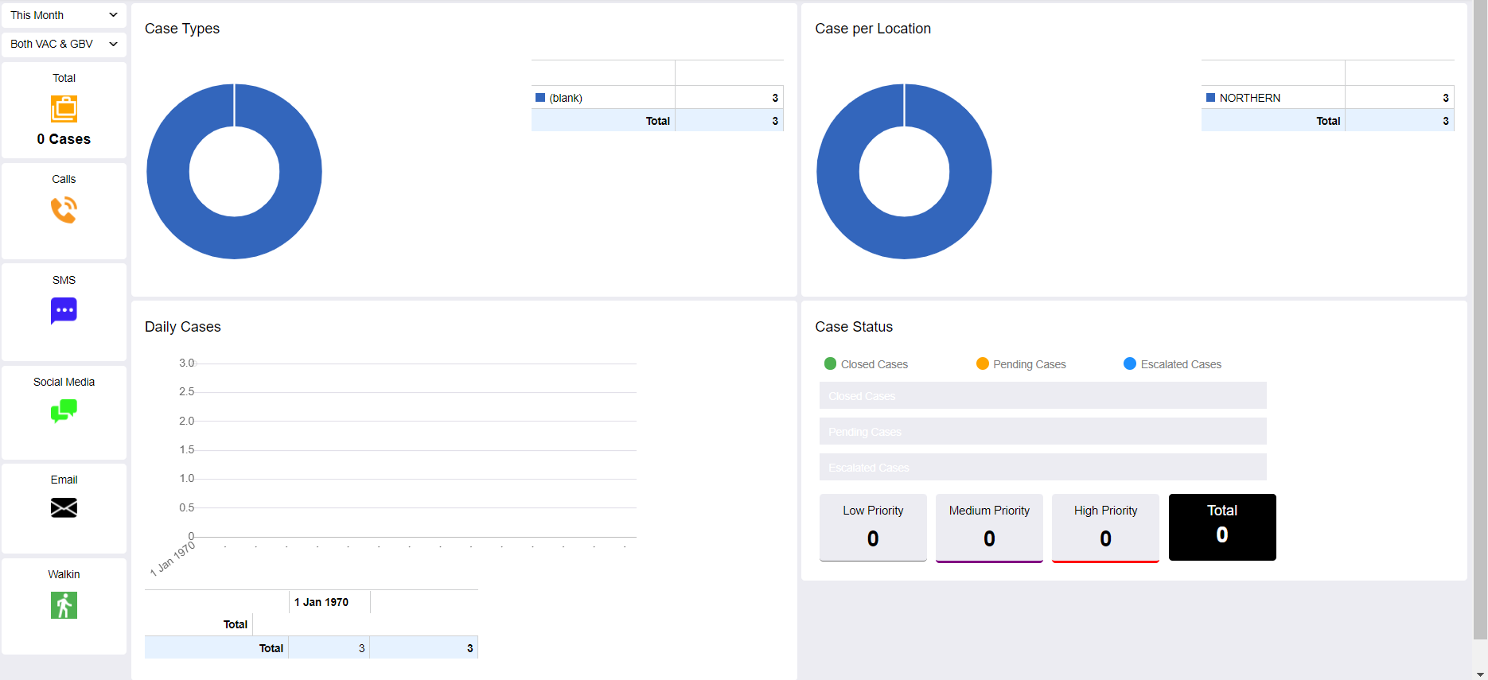

Figure : User Presence Page

# Approval Form

|  |  |
| --- | --- |
| By signing this document, I acknowledge that I have received stated deliverables to the agreed quality levels. | |
|  | **Signature:** |
| **Date:** |
|  | **Signature:** |
| **Date:** |
|  | **Signature:** |
|  | **Date:** |